THE LYME TRUST ANTI-SOCIAL BEHAVIOUR (ASB) AND HARASSMENT POLICY

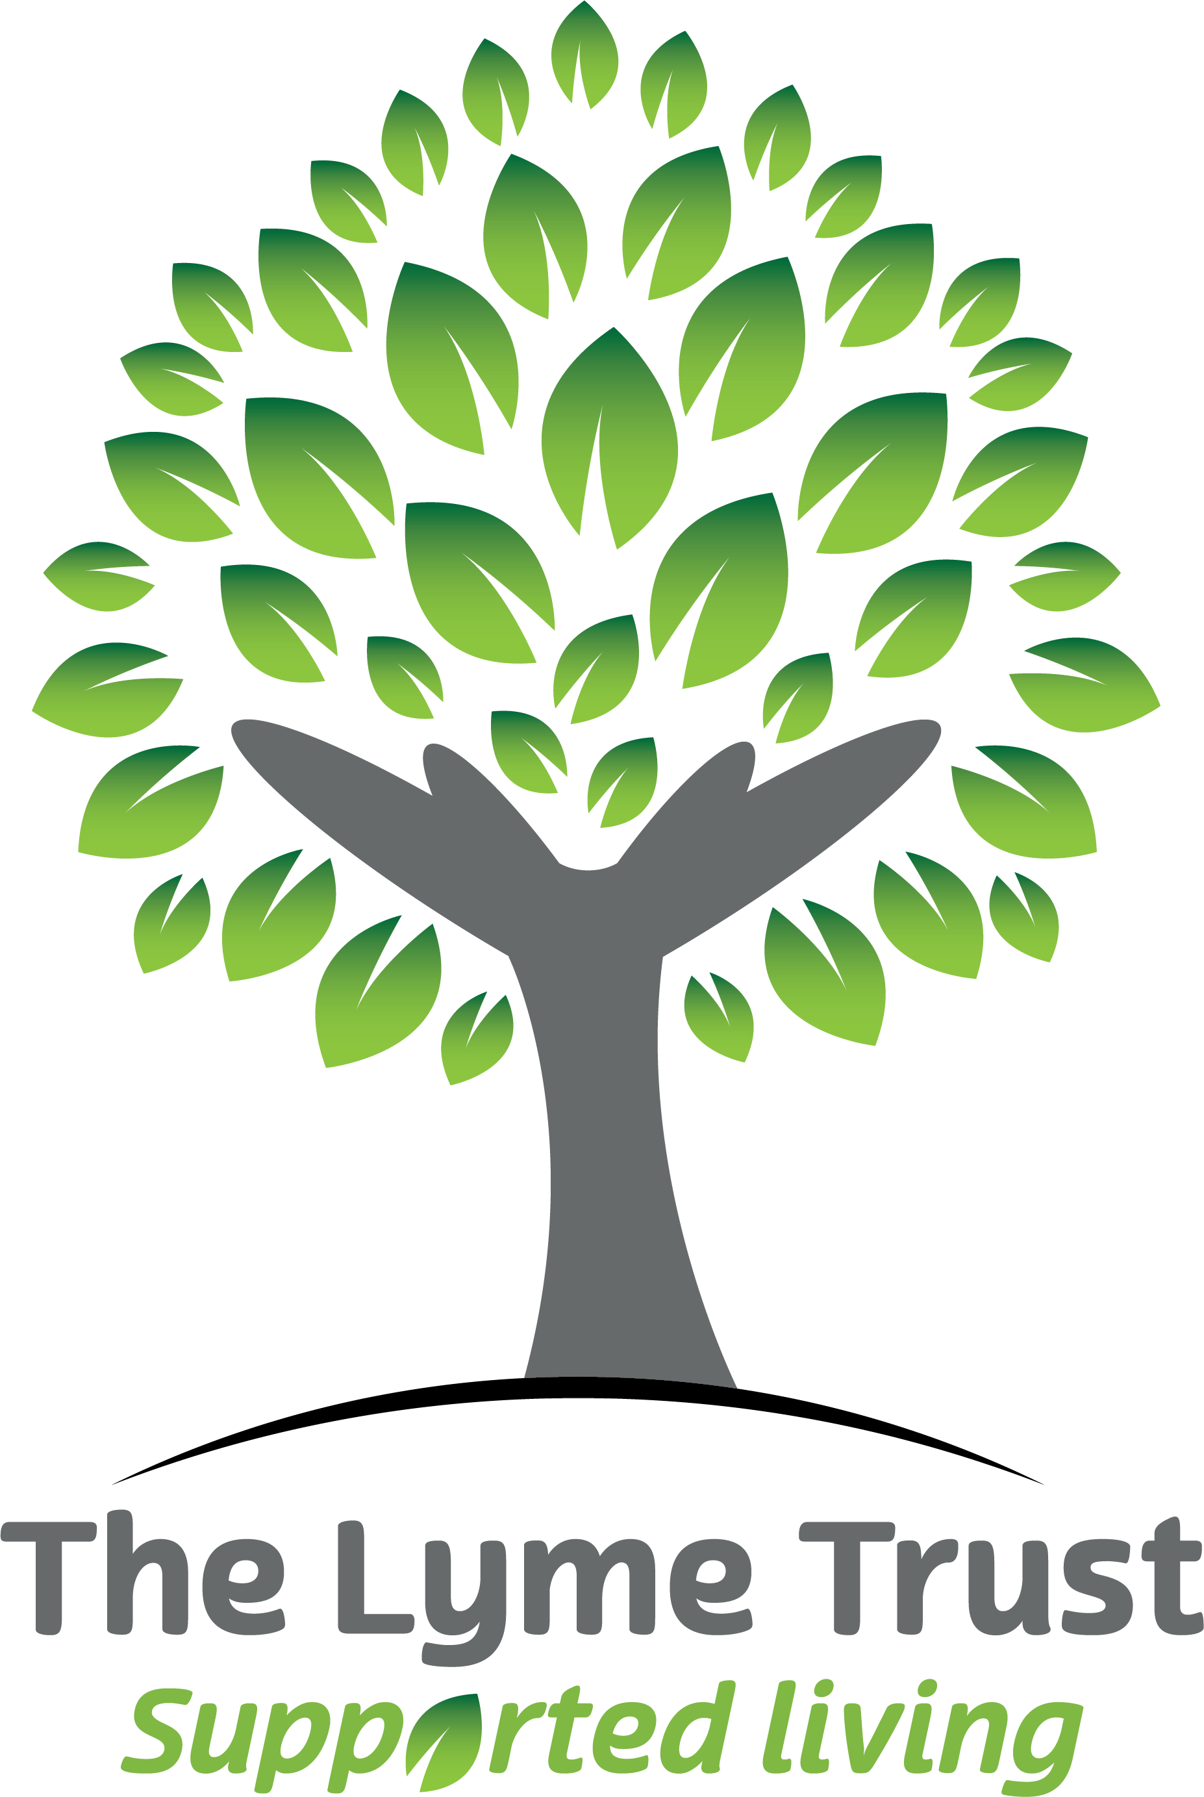

Overview
The Anti-social Behaviour (ASB) and harassment Policy sets out our approach in preventing, managing and resolving ASB and harassment within our accommodation and communities.
Policy statement
The Lyme Trust believe that occupants, employees, the public and the local community should feel safe in our services and the neighbourhoods within which they are located.
The Lyme Trust promote the view that individuals have the right to their chosen lifestyle providing it does not impact adversely on the quality of life of other people or our properties.
Introduction
As a responsible registered provider of social housing and related support, we recognise our role in responding to concerns about ASB. We understand our responsibility to ensure that service users can enjoy their home in peace, free from the fear or threat of intimidation, harassment or abuse of any kind. We also recognise our responsibility to make sure, as far as possible, that the actions of our service users do not interfere with their neighbours’ quiet enjoyment of their home.
We believe that to be effective in our approach we need to have a balance of preventative, enforcement and supportive measures in place. This involves working with a range of partners making the best use of the powers available as well as using our own internal resources in the most effective way.
Policy Aims
The aim of our Anti-Social Behaviour and harassment Policy is to prevent the occurrence where possible, and where cases arise, to deal with them promptly and professionally to seek an outcome that will resolve the issue. We will do this by:
- Raising awareness of how to report ASB and what The Lyme Trust and others can do to address it
- Ensuring that the relevant employees of The Lyme Trust are trained to respond swiftly and effectively to reports of ASB to prevent escalation into more serious incidents
- Developing and maintaining effective partnerships with other agencies with whom we work with to tackle ASB
- Minimising the amount of ASB that our occupants and communities experience through preventative action, rehabilitation of perpetrators and community cohesion activities
- Encouraging and supporting neighbours to resolve issues between themselves where appropriate
- Responding proportionately
- Putting victims first by considering from the outset the effect of ASB and harassment on victims and any risk to them
- Taking a problem-solving approach for each individual case to deliver effective case management
- Assessing the potential risk for ASB with new occupants and putting appropriate preventative measures in place
- Adhering to all relevant legislative and regulatory requirements

Responsibilities
Responsibilities of both The Lyme Trust and service users are set out in the Excluded Licence agreement that are explained to all new service users at sign-up.
In addition, we positively encourage all occupants to:
- Take responsibility for minor personal disputes with their neighbours and to try to resolve any such problems themselves in the first instance in a reasonable manner
- Respect other people at all times
- Co-operate with The Lyme Trust when seeking to resolve problems

We will also assess the risk of the potential impact of ASB prior to the commencement of an occupancy. In situations where, due to an applicant’s housing or life history, their relative vulnerability, and where there have been recent or on-going issues within a neighbourhood, additional measures may be appropriate. This will include tailored support and other provisions to reduce the risk of occupancy failure.
The Lyme Trust’s service users can enjoy occupation of their homes regardless of ethnicity, religion, sexuality, age, gender, disability or any other protected characteristic. All service users are treated in a fair, equitable and consistent manner and we consider the needs and vulnerabilities of our service users when we respond, investigate or take enforcement action during the management of ASB complaints, as outlined in our Warnings and Eviction Policy.
The Lyme Trust are committed to working with others to make the areas within which we operate places that people can live comfortably. Preventing and resolving ASB is a key action in achieving this objective.

Prevention
The Lyme Trust will endeavour to prevent ASB from occurring in the first place where possible. We will do this by:
- The use of Excluded Licence Agreements
- Ensuring all new service users are made aware of their rights and responsibilities in relation to anti-social behaviour and harassment
- Regular property inspections to ensure that properties are clean, safe and secure
- Regular tailored support for all service users
- Close multi-agency working
- Community projects/activities which may assist in reducing ASB and/or harassment
- Using mediation, warnings and rolling eviction notices to address specific behaviour/s
- Consider the use of property transfers/internal moves where necessary

Definition of ASB
We use the following definition of ASB as defined in the Anti-Social Behaviour, Crime and Policing Act 2014 as conduct that:
- Has caused, or is likely to cause, harassment, alarm or distress to any person
- Can cause nuisance or annoyance to a person in relation to that person’s occupation of residential premises
- Can cause housing-related nuisance or annoyance to any person

Harassment
Harassment is defined as a person’s behaviour that makes another person feel distressed, humiliated or threatened. We have a zero-tolerance approach to harassment and manage all reports of harassment in line with this policy.
Hate crime and hate related incidents
Hate crime and related incidents are those perceived by the victim, or any other person, to be motivated by hostility or prejudice based on a personal characteristic. Incidents may manifest themselves in low-level forms of anti-social behaviour but the impact on the victim may be devastating.
Hate crimes are crimes committed against someone because of their: disability, gender identity, race, religion or belief, or sexual orientation and should be reported to the police. We have a zero-tolerance policy to hate crime and hate related incidents and manage all reports in line with this policy.
ASB, harassment and hate-related crime can have devastating effects on communities and individuals. The Lyme Trust put victims at the heart of our response, take a flexible approach to managing incidents and work in partnership with other agencies to tackle it.
Categories of ASB
ASB includes a range of activities (including harassment and hate-related crime), and has many causes.
ASB can include the below categories, this list is not exhaustive:
- Alcohol-related anti-social behaviour
- Drugs/substance misuse/drug dealing
- Other criminal behaviour
- Domestic violence
- Garden/yard nuisance (e.g. not keeping the garden/yard maintained or dumping goods in the garden/yard)
- Harassment
- Hate-related incidents (based on age, disability, gender, race, religion, sexual orientation)
- Fly-tipping
- Misuse of communal areas or public spaces/loitering
- Noise
- Nuisance from vehicles
- Pets and animal nuisance
- Other physical violence
- Prostitution/sexual acts/kerb crawling
- Vandalism and verbal abuse
Living noise
We would also not consider everyday living noises as ASB. Examples of living noises include:
- Doors closing
- Toilets flushing
- DIY noise that is taking place at reasonable hours (7am to 11pm)
- Walking across a floor
Although we understand that this may annoy some residents, unfortunately, this sort of noise is a part of everyday life, and we will not investigate it as ASB.
While everyday living noise will not be investigated as an ASB case, our housing support team may be able to resolve issues in other ways, for example, conducting
more frequent property visits and providing advice and support around reducing noise levels.

The Lyme Trust will categorise ASB complaints as follows:
- Very Serious – this includes (but is not limited to) hate-related incidents, physical violence, threatening behaviour and drug production or supply.
- Serious – this includes (but is not limited to) verbal abuse, harassment, alcohol/drug related ASB, noise nuisance and criminal behaviours.
- Minor – this includes (but is not limited to) vandalism, garden nuisance, vehicle nuisance, animal nuisance and fly tipping.

Dealing with ASB
The Lyme Trust firmly believes that in many incidences, ASB can be addressed when challenged early enough. The vast majority of ASB reports will not require enforcement action and will be effectively resolved through early intervention by our staff. Early intervention may include mediation, verbal and written warnings or the use of a rolling notice of eviction, which is a behavioural agreement.
- Our response to allegations of ASB and/or harassment will, always be reasonable and proportionate in the circumstances. Each case will be dealt with on a case-by-case basis depending on individual circumstances. What we do in one case does not automatically mean that we will adopt the same approach in another.
- We also aim to provide a balanced approach, protecting the quiet enjoyment of the community while helping individuals to sustain their occupancies by addressing their behaviour.
- To tackle ASB and harassment effectively, we will take the following actions.
- Demonstrate leadership, accountability and commitment in working with statutory partners to tackle ASB so that we all fulfil our respective responsibilities
- Ensure staff are well trained, have the knowledge and confidence to identify and investigate incidents/reports of ASB and harassment and work collaboratively alongside appropriate agencies who are leading on such cases
- Assess each report of ASB on its own merits and specific circumstances when deciding whether, or not, to classify it as ASB
- Respond to ASB and harassment in line with the severity of the incident
- Be clear about what action we can or cannot take
- Provide advice and information
- Log all reports of ASB and any referrals to statutory bodies and monitor the outcomes
- Respond sensitively to the victim and adopt high standards of confidentiality when dealing with victims and witnesses
- Adopt a victim-centred approach in responding to harassment and hate crime
- Offer advice and signposting to appropriate third-sector support for witnesses and victims of ASB
- Ensure we consider a range of interventions (e.g. education, intensive support, verbal/written warnings, rolling notice of eviction – this list is not exhaustive) to deter ASB
- Ensure vulnerable perpetrators understand the impact of their actions and give them an opportunity to change their behaviour via provision of ongoing support to help them make the changes necessary to prevent a re-occurrence of the ASB
- Take action to evict a perpetrator where it is reasonable and proportionate to do so and the evidence is sufficient and robust
- Use information and performance data against targets to ensure continuous improvement
Confidentiality, Data Protection Act 1988 and information sharing
Whilst we respect privacy, confidentiality, and are mindful of our obligations under the Data Protection Act 1988, tackling ASB requires robust information exchange between statutory and non-statutory agencies.
We will also share information with other relevant agencies where appropriate and will actively participate in partnership arrangements to safeguard vulnerable adults.
When dealing with anti-social behaviour, hate crime and domestic abuse, full consideration will be given to our safeguarding responsibilities.
Information will be handled and disseminated on a need-to-know basis. The correct information will be stored securely with limited access to the designated people and for the required time in line with General Data Protection Regulations and the confidentiality policy.

Responsibility
The Operations Director is responsible for the monitoring and review of this policy.
The Lyme Trust Operations Director is responsible for ensuring the implementation of this policy and supporting procedures for the maintenance of all necessary records on the RMS system to enable the compilation of regular reports on performance and for the monitoring of performance.

